**INFO6210 Online Retail Management System**

**Database Specifications: - Purpose, Business Problems Addressed and Business Rules**

Nikhil Joshi, Krishna Singh, Utkarsh Kakkar, Swati Pandey

**Database Purpose**: -

The Purpose of this Database will be to eliminate the unnecessary customer’s painstaking task of searching for cheaper deals by providing him a platform wherein the system will give the prices and vendor details which eventually helps to choose best deal achieved through amalgamation of multiple websites or applications (Amazon, eBay, Flipkart, etc.)

**Business Problems Addressed**: -

* Allow price lists of products based on ratings, reviews, products sold on high prices
* Provide a transparency between the website and customer.
* Permits visualizing the sales based on which vendors and products are being picked up the most from which website.
* Helps in propaganda of local vendors amongst users which enhance relationship model between the sellers, vendors, suppliers, customers.
* Allows better view when order has been placed by customer for tracking purpose.

**Business Rules**: -

* Each Order will have one or more Products.
* Each Customer may have zero or more Orders.
* Each Customer will have a CustomerAddress.
* A product can or cannot be in a CartItem. It is not mandatory.
* Each customer will use one or more than one ShoppingSite.
* One Successful payment will result in generating a single invoice.
* A product will mandatorily have a single Brand name.

**Design Requirements** (**Credit to Professor Simon Wang**): -

* Use Crow’s Foot Notation.
* Draw line between entities for displaying relationships between them. This line should be pointed directly to the fields of each table that are in relationship.
* Specify primary key in each table by specifying **PK** besides the attributes.
* Specify foreign key in each table by specifying **FK** besides the attributes.
* Specify whether the relationship is **Identifying** by using “Hard Line” between two entities.
* Specify whether the relationship is **Non-Identifying** by using “Dotted Line” between two entities.
* Specify which table is on one side of the relationship by denoting it by one next to attribute where line starts.
* Specify which table is zero side of the relationship by denoting it by zero next to attribute where line starts.
* Specify which table is on many sides of the relationship by denoting it by “**Crow’s Feet**” symbol next to attribute where line starts.

**Design Decisions**: -

|  |  |  |
| --- | --- | --- |
| **Entity Name** | **Why is it Included** | **How it is related with other entities** |
| Customer | The primary purpose of this database is to store the information related to the user, in order to purchase the product. | The Customer entity has CustomerID, UserID as its primary key and AddressID, CustomerTypeId as the foreign keys. Customer is related to Order, ShoppingSite, CustomerAddress |
| User Type | This entity defines what kind of users daily interact with the application using the given database. Depending upon the different user role credentials the given database will be referred. | UserType is related to User entity. It gives the information regarding the role of user for example if the user has special privileges for getting discounted rates or not |
| Product | This is one of primary key entities of database which will store the product details like **product quantity**, **product batch code** etc. | Product entity is a crucial entity related directly to brand entity. It is also related to CartItem, ProductType and Employee with multi value cardinality. |
| Supplier | This entity specifies the bulk amount of goods delivered to the store house/inventory with the help of some attributes like **supply dispatch date, supply arrival date, supply quantity** etc. | Supplier is connected to inventory entity, which flows to product and makes the relationships seamless. |
| Order | This key entity is used to keep track of which products do the user prefers to buy and the given database can be used further used to analyze and prepare reports. | Order is related to Customer and Payment entity. It is also linked with an associative entity to resolve many to many relationships between Product entity. |
| Payment | This entity provides enough information on which mode of payment does the user opts for in order payoff the order value. Also, which type of payment (i.e. **Debit, Credit, COD**) customer prefers to pay. | Payment is related to invoice and order. Information comes through orders for payment and it flows to invoice. |
| CustomerAddress | This is the entity which allows users to store addresses. There can be multiple addresses for one user credential, or one address shared by multiple user credentials. There can be different types of address for one credential | Customer is related to Customer Address which is non identifying type of relationship. |
| Brand | This entity will have the information regarding different types of brands and their availability according to which a user or a supplier will get the details. Will help to keep a track of the ratings and products most preferred by the users. | Brand is linked with product as a one to one relationship. A product must have a brand name which will allow us eventually to calculate the revenue collected by a single brand. |
| Employee | This is key entity describing which employee is more capable of delivering the intended result as to how many orders are successfully delivered out of total orders. | Employee is linked to CustomerAddress, EmployeeType and product in a one to many relationship. Depending upon the type of an employee, we can link it to EmployeeType example Deliveryman will be linked to customerAddress. |
| Employee Type | This entity defines which role is assigned to which employee depending upon the duties given to him. | EmployeeType is linked only to Employee in a one to one relationship. |
| Inventory | This is primary entity underlining the total available quantity of each product received from the supplier. Also helps to keep track of what products will be at their lowest quantity. | Inventory is linked to product and Supplier. It gets the information from supplier and this information flows to Supplier. |
| Invoice | This entity describes user’s proclivity towards which product is more as it gives a clear picture through attributes like **product name, product quantity, amount** etc. | Invoice is linked to payment in a one to one relationship. Every successful payment will have an invoice generated. |
| Cart Item | This entity defines what branded products are ordered by user frequently. | CartItem is linked with product entity in an optional one to many relationship. |
| ShoppingSite | This entity enables us the information regarding customer’s shopping preferences and the shopping site it chooses for ordering or the time consumed on it. | ShoppingSite is only linked to Customer. It will |
| User | User entity enables contains the username and password of every customer. | A User Entity is directly connected to Customer entity. |

**ER Diagram:**

**Changes Made for the Final ERD:**

* The one to many relationships between Order and Product is reversed.
* In Product table, BrandID is not the primary key, only ProductID is the primary key now.
* In CartIem table, SiteID is now only primary key
* Customer table is now connected to CartItem instead of Product
* Relationship between customer and CartItem is now Non-Identifying type
* Relationship between UserType and User is now one-to-many and Non-Identifying type
* Relationship between Brand and Product is now one-to-many and Identifying type
* Relationship between Supplier and Inventory is now one-to-many and Identifying type
* SupplierAddress is now a new Entity
* Relationship between Employee and EmployeeType is now one-to-many and Non-Identifying type
* Invoice contains only 2 attributes now
* CardDetails entity is added to the ERD and linked with Customer entity

**Updated ERD:**

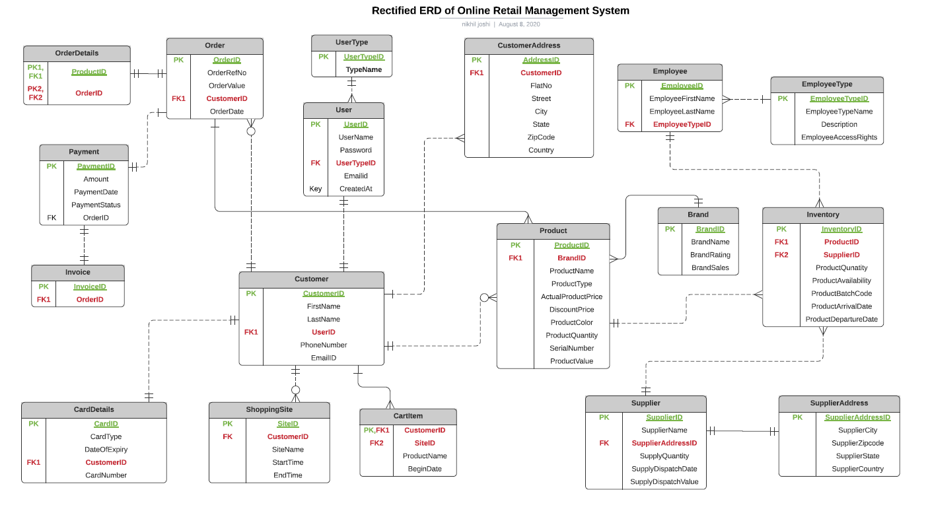

There have been 2 new Entities that are added to the Entity-Relationship Diagram which are explained below:

|  |  |  |
| --- | --- | --- |
| **Entity Name** | **Why is it Included** | **How it is related with other entities** |
| Supplier Address | It includes the details of the supplier like address which includes city country, etc. | It has one and only one relationship with the supplier entity. |
| Cart Item | Includes the details of the of the product name, product value along with SiteID and CustomerID | It has one to many relationship with the Customer Entity along with CustomerID acting as Composite Key |
| OrderDetails | Includes the primary key of Product and Orders Entity | It has one to one relationship with Order entity |
| CardDetails | Includes details of CardID, CardType, CardNumber etc | It has one to one relationship with Customer entity |